

HARDCAT USER ACCOUNT MANAGEMENT PROCEDURE

Document No: | IMST-Proc-005
Version: | 1.1
Authors: | ASSET MANAGEMENT & IMST
Effective Date: | 01/04/2016
Electronic File: | Treasury website\online systems\Supporting & Interlinked Financial Systems\Hardcat manuals

KZN PROVINCIAL TREASURY

Contents

- Hardcat User Account Management Procedure..................................2

- Introduction…………….…………………………………………….3

- Purpose..................................................................................................3

- Procedure for creating Hardcat User.....................................................3

- Procedure for deactivating Hardcat User..............................................4

- Procedure for removing Hardcat User.................................................5

- Procedure for amending Hardcat User.................................................5

- Procedure for resetting Hardcat passwords...........................................5

- User Ids and password security standards.............................................6

- Periodic Checks……………………………………………………….8

- Independent reviews………………………………………………….9

- Monthly Reports……………………………………………………..9

- Monitoring of access and logon violations…………………………..9

- Hardcat Access Levels........................................................................10

Annexure D: Hardcat User Application Form
Annexure E: Hardcat Reset Form
Annexure F: Process Flow Diagram

Introduction

To ensure compliance with minimum security standards and general controls surrounding information systems it is necessary to detail and outline the procedure for the management of Hardcat user accounts and the available access levels.

Purpose

The purpose of this document is to outline the procedure for the creation/ amending/ resetting/deletion and deactivation of Hardcat users to increase system security and eliminate possible threats associated with security of user accounts. The document also provides an outline of the different types of Hardcat users with their respective access levels depending on their job functions.

Procedure for creating a New User

- Provincial Treasury’s Systems Support User (Departmental Super User) –
  - A new user must complete and sign the Hardcat User Application Form (Annexure D).
  - Provincial Treasury’s Super User will be created by the Admin User and linked to all departments.
  - Then the Super User will create Systems Support User and link him/her to the departments he/she supports.
  - The Hardcat User Application Form must also be signed by the Supervisor /Manager of the applicant.
  - The signed form must be submitted to the Provincial Treasury’s Hardcat Super User or Admin. User.
  - The Provincial Treasury’s Hardcat Super/ Admin. User will create the applicant on Hardcat, allocating the access levels.
  - Once the applicant has been created on the system, the Super User/ Admin. User will sign and file the form for audit purposes.
  - The Super User/ Admin. User will then inform the applicant via an e-mail or other means immediately after the user name and password has been created.
- System Controller- Departments
  - A new user will complete and sign the Hardcat User Application Form(Annexure D)
  - The Hardcat User Application Form must be signed by the Supervisor/Manager of the applicant.
  - The signed form together with a memo appointing the official as a Sycon must be submitted to the Hardcat Systems Support User at Provincial Treasury.
  - The Hardcat Systems Support User will then create the user on Hardcat, allocating access levels.
  - Once the applicant has been created on the system, the Systems Support User will sign and file the form together with the memo for audit purposes.
  - The Systems Support User will then inform the applicant via an e-mail or other means immediately after the username and password has been created.
- Normal Hardcat User - Departmental
  - A new user (departmental) will complete and sign the Hardcat User Application Form (Annexure D).
  - The Hardcat User Application Form must be signed by the Supervisor /Manager of the applicant.
  - The signed form must be submitted to the Hardcat System Controller.
  - The Hardcat Syscon will then create the new user on Hardcat allocating the access levels according to the official job functions.
  - Once the applicant has been created on the system, the System Controller will sign and file the form for audit purposes.
  - The System Controller will then inform the applicant via an e-mail or other means immediately after the username and password has been created.
- Procedure for Deactivating the User Account
  - The Supervisor/Manager must inform the System Controller/ Systems Support User/ Super User/ Administrator in writing of users that left the department.
  - The System Controller, Systems Support User, Super User or Administrator must deactivate the user on the system and inform the Supervisor/Manager about the deactivation of the user in writing.
  - The Hardcat User Application Form must be completed and signed by the Supervisor/Manager.

- Procedure for Removing a User Account
  - The System Controller, Systems Support User, Super User or Administrator will disable the user account which has been inactive for more than 30 days. User accounts which have been inactive for more than 6 months will be removed.
  - All inactive users with records associated with them remain in the system for future reference for a period that will be prescribed by Provincial Treasury.
  - The Hardcat User Application Form must be used in this regard;
- Procedure for Amending a User Account.
  - Applicant must complete and sign the Hardcat User Application Form and mark the appropriate box for amendments.
  - The Hardcat User Application Form should be signed by the Supervisor/Manager and forwarded to the Departmental Hardcat Syscon.
  - The Departmental Hardcat Syscon will then effect the requested amendments and sign and file the form for audit purposes.
  - The System Controller will then inform the applicant via an e-mail or other means immediately after the amendments have been made.
- Procedure for Resetting of Passwords.
  - Applicant will complete and sign the Hardcat Reset Form (Annexure E).
  - The Hardcat Reset Form must be signed by the Supervisor/Manager and forwarded to the Hardcat Syscon.
  - The Hardcat Syscon will then reset the user password on Hardcat.
  - Once the applicant has been reset on the system, the Syscon will sign and file the form for audit purposes.
  - The System Controller will then inform the applicant via an e-mail or other means immediately after the user has been reset.

8. Userid and password minimum security standards (Hardcat notice no. 1 of 2007)

- All userid's must have passwords,
- All Passwords must expire after 30 Days,
- The length of passwords must be enforced to be a minimum of 6 characters (preferably alpha numeric characters with both lower and upper cases).
- All users on the database must be set to 1 in “maximum users” under multiple user check boxes,
- All Databases must time out after a maximum of 15 minutes or less of inactivity,
- No user must have administration rights without direct permission from Provincial Treasury,
- No user must have user creation rights without direct permission from Provincial Treasury,
- All users must be created as internal users, with the exception of the interface username,
- A user who has a responsibility to create other users(Syscon) must not have access to capturing or authorizing functions on Hardcat. If the Department cannot assign a separate user for this, Provincial Treasury will take over this function on behalf of the Department,
- The system should disconnect when logon is unsuccessful(Suggested modification),
- Users should be restricted to working hours only, however requests to work overtime and during weekends will have to be made in writing through e-mail or a letter, the Syscon will then grant access for that specific time requested. (Suggested modification),
- There should be a force logoff after working hours (suggested modification),
- User id’s should blocked after 3 incorrect logon attempts (Incorrect Login Count =3), (modification pending),
- Users could logon to several workstations simultaneous due to the fact that the “multiple user option does not work properly, (i.e. when restricting the user to only
one login, when the system kicks out the user due to a slow response time as a result of network problems, the user id gets revoked, and it required to be reset by the system controller, therefore users are allowed to have multiple user option set to only 2 until the system is modified).
- Password protected screen savers should be implemented on sensitive workstations (Syscon),
- There should be an automatic disconnection from the network after a set time of 15 minutes of inactivity,
- The system should detect intruder = yes (Suggested modification),
- The system should lock account after detection = yes,
- All job functions should be review for sensitivity levels (e.g. Payments),
- Access levels must be in line with the duties to be performed as per the job description or as authorized by the supervisor of the applicant and there should be correct segregation of duties between the capturer and the authorizer,
- Before granting access to users, care must be taken to ensure that sensitive functions are performed by different individuals (Segregation of duties),
- Distinct support functions must be performed by a different individual (Support Official) with access levels as indicated below,
- All user id’s must be assigned to appropriate workflow groups,
- Users must sign the Hardcat User Application Form to accept the declaration part of it as a mechanism to hold them accountable for their actions,
- In the case of long vacation and/or job shifts/rotations necessary amendments must be made on Hardcat user accounts,
- No individuals should be authorized to bypass significant technical and operational controls screen prior to access Hardcat and periodically thereafter,
- Confidentiality and security agreements are required for employees assigned to work with sensitive information,
- When controls cannot adequately protect the information, employees are screened prior to access,
- There should be a direct communication between systems and human resources in terms of hiring, transfer, and terminations with a view of updating and managing the user accounts,
- The process of requesting, establishing, issuing, and closing user accounts must be followed regardless of whatever situation arise.
- All Suppliers on Hardcat must be authorized by a different user other than the user who captured the supplier. The Supplier must also have ZNT Numbers unless these have been excluded in terms of the SCM 01 Supplier Database practice note.
- The Syscon should at least once per quarter verify all user accounts and make possible investigation to confirm if users still use and require the access levels previously given e.g. by requesting all users to re-apply where possible and convenient .

- The departments Syscon should on a weekly basis draw user activity report to identify inactive user accounts and deactivate those users as per the Hardcat Practice Note 1.

- The supervisor of the Treasury’s Systems Supporter and the departmental Syscon should on a monthly basis request Hardcat system, log and user reports to monitor the departments' Syscon's and user’s activities.

- The activities of the Systems Support User will be monitored by his/her Supervisor/Manager in the form of weekly status reports and monthly reports.

- Periodic Checks
At least once per quarter all user access rights must be checked to ensure that they are still commensurate with the users’ job responsibilities. For small departments this exercise can be performed on a monthly basis if they so wish.
During periodic check of user accounts, there may be a need to deactivate all user accounts and request all users to re-apply. Necessary communication must be made to all deactivated users who will be requested to re-apply.

- Independent Review
All activities conducted by the Systems Support User, Administrator and the Syscon regarding the user id maintenance must be independently reviewed by their respective Senior Managers on a quarterly basis to ensure that such maintenance related to valid and approved user id requests.
- Monthly Reports
Based on the information provided by Human Resources regarding the termination of services of staff, necessary steps must be immediately taken by the (Systems Support User in the case of Syscon or the Syscon in the case of normal user) to remove access levels for those staff members whose services have been terminated. The people hierarchy on Hardcat must be verified and updated by the Syscon.
- Monitoring of Access and logon violations
At least on a monthly basis there should be an exercise to monitor the logon violations on Hardcat, relevant reports can be drawn on Hardcat and suspicious attempts be investigated and dealt with accordingly.

14. Hardcat Access Level
Job Function: Asset Capturer
Access Levels:
 |  |  |  |  | ACCESS REQUIRED |  |  | (N = None, R = Read only, RA = Read/Amend, RAD = Read/Amend/Delete)
 | ADMINISTRATION |  |  |  | R |  | BARCODING |  | RA |  | STOCK |  |  | N |  | PEOPLE |  | R
 | FINANCIAL |  |  |  | RA |  | DEPRECIATION |  | N |  | ASSETS |  |  | RA |  | PRODUCTS |  | R
 | EXPORT |  |  |  | RAD |  | HELP DESK |  | N |  | LOCATIONS |  |  | R |  | ASSET TYPES |  | R
 | IMPORT |  |  |  | R |  | PURCHASING |  | N |  | SUPPLIERS |  |  | R |  | USERS |  | R
 | REPORTS |  |  |  | RAD |  | MAINTENANCE |  | N |  | COST CENTRES |  |  | R
Options:
ASSETS | GENERAL | HELP DESK | MAINTENANCE | PURCHASING
Uncheck all | Uncheck all except “Generate” HTML reports when sending. | Uncheck all | Uncheck all | Uncheck all  Purchasing Authority limit = R0.00

Job Function: Asset Verification
Capturer: Yes (No authorizer)
Access Levels:
 |  |  |  |  | ACCESS REQUIRED |  |  | (N = None, R = Read only, RA = Read/Amend, RAD = Read/Amend/Delete)
 | ADMINISTRATION |  |  |  | RAD |  | BARCODING |  | RAD |  | STOCK |  |  | N |  | PEOPLE |  | RA
 | FINANCIAL |  |  |  | RA |  | DEPRECIATION |  | R |  | ASSETS |  |  | RA |  | PRODUCTS |  | RA
 | EXPORT |  |  |  | RAD |  | HELP DESK |  | N |  | LOCATIONS |  |  | RA |  | ASSET TYPES |  | RA
 | IMPORT |  |  |  | RAD |  | PURCHASING |  | N |  | SUPPLIERS |  |  | R |  | USERS |  | R
 | REPORTS |  |  |  | RAD |  | MAINTENANCE |  | N |  | COST CENTRES |  |  | R

Options:
ASSETS | GENERAL | HELP DESK | MAINTENANCE | PURCHASING
Uncheck all | Uncheck all except “Generate” HTML reports when sending. | Uncheck all | Uncheck all | Uncheck all  Purchasing Authority limit = R0.00

Job Function: Capture Purchase Orders

Access Levels:
 |  |  |  |  | ACCESS REQUIRED |  |  | (N = None, R = Read only, RA = Read/Amend, RAD = Read/Amend/Delete)
 | ADMINISTRATION |  |  |  | N |  | BARCODING |  | N |  | STOCK |  |  | N |  | PEOPLE |  | R
 | FINANCIAL |  |  |  | RA |  | DEPRECIATION |  | N |  | ASSETS |  |  | R |  | PRODUCTS |  | R
 | EXPORT |  |  |  | R |  | HELP DESK |  | N |  | LOCATIONS |  |  | R |  | ASSET TYPES |  | R
 | IMPORT |  |  |  | R |  | PURCHASING |  | RAD |  | SUPPLIERS |  |  | R |  | USERS |  | N
 | REPORTS |  |  |  | RAD |  | MAINTENANCE |  | N |  | COST CENTRES |  |  | N
Options:
ASSETS | GENERAL | HELP DESK | MAINTENANCE | PURCHASING
Uncheck all | Uncheck all except “Generate” HTML reports when sending. | Uncheck all | Uncheck all | 1. Check “Can create/edit Purchase Orders”  2. Check “ Can cancel Purchase Orders”  4. Assign a purchasing authority limit.

Job Function: Authorize Purchase Orders

Access Levels:
 |  |  |  |  | ACCESS REQUIRED |  |  | (N = None, R = Read only, RA = Read/Amend, RAD = Read/Amend/Delete)
 | ADMINISTRATION |  |  |  | RAD* |  | BARCODING |  | N |  | STOCK |  |  | N |  | PEOPLE |  | R
 | FINANCIAL |  |  |  | RA |  | DEPRECIATION |  | N |  | ASSETS |  |  | N |  | PRODUCTS |  | R
 | EXPORT |  |  |  | R |  | HELP DESK |  | N |  | LOCATIONS |  |  | R |  | ASSET TYPES |  | R
 | IMPORT |  |  |  | R |  | PURCHASING |  | RAD |  | SUPPLIERS |  |  | R |  | USERS |  | N
 | REPORTS |  |  |  | RAD |  | MAINTENANCE |  | N |  | COST CENTRES |  |  | N
Options:
ASSETS | GENERAL | HELP DESK | MAINTENANCE | PURCHASING
Uncheck all | Uncheck all except “Generate” HTML reports when sending. | Uncheck all | Uncheck all | 1. Check “Can adjust confirmed Purchase Orders”  2. Check “Can confirm Purchase Orders”  3. Check “Can cancel Purchase Orders”*  4. Assign a purchasing authority limit.

* = RAD under administration is required for the user id to be able to unconfirm purchase orders (System requirement)

Job Function: Capture Invoices

Access Levels:
 |  |  |  |  | ACCESS REQUIRED |  |  | (N = None, R = Read only, RA = Read/Amend, RAD = Read/Amend/Delete)
 | ADMINISTRATION |  |  |  | N |  | BARCODING |  | N |  | STOCK |  |  | N |  | PEOPLE |  | R
 | FINANCIAL |  |  |  | R |  | DEPRECIATION |  | N |  | ASSETS |  |  | N |  | PRODUCTS |  | R
 | EXPORT |  |  |  | R |  | HELP DESK |  | N |  | LOCATIONS |  |  | R |  | ASSET TYPES |  | R
 | IMPORT |  |  |  | R |  | PURCHASING |  | RA |  | SUPPLIERS |  |  | R |  | USERS |  | N
 | REPORTS |  |  |  | RAD |  | MAINTENANCE |  | N |  | COST CENTRES |  |  | N
Options:
ASSETS | GENERAL | HELP DESK | MAINTENANCE | PURCHASING
Uncheck all | Uncheck all except “Generate” HTML reports when sending. | Uncheck all | Uncheck all | 1. Check “Can create/edit Invoice details”  2. Check “Can create/edit Purchase Orders”  3. Assign a purchasing authority limit.

Job Function: Authorize Invoice

Access Levels:
 |  |  |  |  | ACCESS REQUIRED |  |  | (N = None, R = Read only, RA = Read/Amend, RAD = Read/Amend/Delete)
 | ADMINISTRATION |  |  |  | N |  | BARCODING |  | N |  | STOCK |  |  | N |  | PEOPLE |  | R
 | FINANCIAL |  |  |  | R |  | DEPRECIATION |  | N |  | ASSETS |  |  | N |  | PRODUCTS |  | N
 | EXPORT |  |  |  | R |  | HELP DESK |  | N |  | LOCATIONS |  |  | R |  | ASSET TYPES |  | R
 | IMPORT |  |  |  | R |  | PURCHASING |  | RA |  | SUPPLIERS |  |  | R |  | USERS |  | N
 | REPORTS |  |  |  | RAD |  | MAINTENANCE |  | N |  | COST CENTRES |  |  | RA
Options:
ASSETS | GENERAL | HELP DESK | MAINTENANCE | PURCHASING
Uncheck all | Uncheck all except “Generate” HTML reports when sending. | Uncheck all | Uncheck all | 1. Check “Can authorize payment”  2. Check”Can create/Edit Purchase Orders”  3. Check “Can create/edit Invoice details”  2. Assign a purchasing authority limit.

Job Function: Capture Suppliers

Access Levels:
 |  |  |  |  | ACCESS REQUIRED |  |  | (N = None, R = Read only, RA = Read/Amend, RAD = Read/Amend/Delete)
 | ADMINISTRATION |  |  |  | RAD |  | BARCODING |  | N |  | STOCK |  |  | N |  | PEOPLE |  | N
 | FINANCIAL |  |  |  | N |  | DEPRECIATION |  | N |  | ASSETS |  |  | N |  | PRODUCTS |  | R
 | EXPORT |  |  |  | N |  | HELP DESK |  | N |  | LOCATIONS |  |  | N |  | ASSET TYPES |  | R
 | IMPORT |  |  |  | N |  | PURCHASING |  | N |  | SUPPLIERS |  |  | RAD |  | USERS |  | N
 | REPORTS |  |  |  | RAD |  | MAINTENANCE |  | N |  | COST CENTRES |  |  | N

Options:
ASSETS | GENERAL | HELP DESK | MAINTENANCE | PURCHASING
Uncheck all | Uncheck all except “Generate” HTML reports when sending. | Uncheck all | Uncheck all | Uncheck all

Job Function: Authorize suppliers

Access Levels:
 |  |  |  |  | ACCESS REQUIRED |  |  | (N = None, R = Read only, RA = Read/Amend, RAD = Read/Amend/Delete)
 | ADMINISTRATION |  |  |  | R |  | BARCODING |  | N |  | STOCK |  |  | N |  | PEOPLE |  | N
 | FINANCIAL |  |  |  | N |  | DEPRECIATION |  | N |  | ASSETS |  |  | N |  | PRODUCTS |  | R
 | EXPORT |  |  |  | N |  | HELP DESK |  | N |  | LOCATIONS |  |  | N |  | ASSET TYPES |  | R
 | IMPORT |  |  |  | N |  | PURCHASING |  | N |  | SUPPLIERS |  |  | RAD |  | USERS |  | N
 | REPORTS |  |  |  | RAD |  | MAINTENANCE |  | N |  | COST CENTRES |  |  | N

Options:
ASSETS | GENERAL | HELP DESK | MAINTENANCE | PURCHASING
Uncheck all | Uncheck all except “Generate” HTML reports when sending.  Can authorize Suppliers | Uncheck all | Uncheck all | Uncheck all

Job Function: System Controller
Syscon: Yes (No authorizer)
Access Levels:
 |  |  |  |  | ACCESS REQUIRED |  |  | (N = None, R = Read only, RA = Read/Amend, RAD = Read/Amend/Delete)
 | ADMINISTRATION |  |  |  | RAD |  | BARCODING |  | N |  | STOCK |  |  | N |  | PEOPLE |  | R
 | FINANCIAL |  |  |  | N |  | DEPRECIATION |  | N |  | ASSETS |  |  | N |  | PRODUCTS |  | N
 | EXPORT |  |  |  | N |  | HELP DESK |  | N |  | LOCATIONS |  |  | N |  | ASSET TYPES |  | N
 | IMPORT |  |  |  | R |  | PURCHASING |  | N |  | SUPPLIERS |  |  | N |  | USERS |  | RAD
 | REPORTS |  |  |  | RAD |  | MAINTENANCE |  | N |  | COST CENTRES |  |  | N

Options:
ASSETS | GENERAL | HELP DESK | MAINTENANCE | PURCHASING
Uncheck All | Uncheck All except “Can edit other users  reports | Uncheck All | Uncheck All | Uncheck All

Job Function: Treasury-System Supporter (Departmental Super User)

Access Levels:
 |  |  |  |  | ACCESS REQUIRED |  |  | (N = None, R = Read only, RA = Read/Amend, RAD = Read/Amend/Delete)
 | ADMINISTRATION |  |  |  | RAD |  | BARCODING |  | RAD |  | STOCK |  |  | RAD |  | PEOPLE |  | RAD
 | FINANCIAL |  |  |  | RAD |  | DEPRECIATION |  | RAD |  | ASSETS |  |  | RAD |  | PRODUCTS |  | RAD
 | EXPORT |  |  |  | RAD |  | HELP DESK |  | RAD |  | LOCATIONS |  |  | RAD |  | ASSET TYPES |  | RAD
 | IMPORT |  |  |  | RAD |  | PURCHASING |  | RAD |  | SUPPLIERS |  |  | RAD |  | USERS |  | RAD
 | REPORTS |  |  |  | RAD |  | MAINTENANCE |  | RAD |  | COST CENTRES |  |  | RAD

Options:
ASSETS | GENERAL | HELP DESK | MAINTENANCE | PURCHASING
Check All | Check All except “Can authorize suppliers” and “Can edit other users reports | Check All | Check All | Uncheck All except “Can maintain Budgets”  Don’t assign a purchasing limit.

Job Functions: Generate Custom and Fixed Reports only

Access Levels:
 |  |  |  |  | ACCESS REQUIRED |  |  | (N = None, R = Read only, RA = Read/Amend, RAD = Read/Amend/Delete)
 | ADMINISTRATION |  |  |  | N |  | BARCODING |  | R |  | STOCK |  |  | N |  | PEOPLE |  | R
 | FINANCIAL |  |  |  | R |  | DEPRECIATION |  | R |  | ASSETS |  |  | R |  | PRODUCTS |  | R
 | EXPORT |  |  |  | RAD |  | HELP DESK |  | N |  | LOCATIONS |  |  | R |  | ASSET TYPES |  | R
 | IMPORT |  |  |  | N |  | PURCHASING |  | R |  | SUPPLIERS |  |  | R |  | USERS |  | R
 | REPORTS |  |  |  | RAD |  | MAINTENANCE |  | N |  | COST CENTRES |  |  | R

Options:
ASSETS | GENERAL | HELP DESK | MAINTENANCE | PURCHASING
Uncheck all | Uncheck all except “Generate” HTML reports when sending. | Uncheck all | Uncheck all | Uncheck all

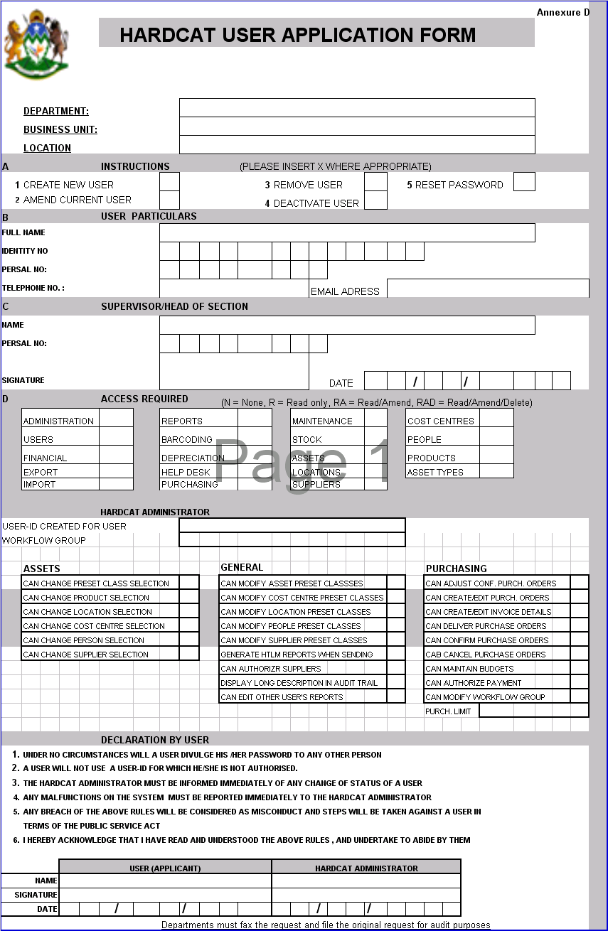

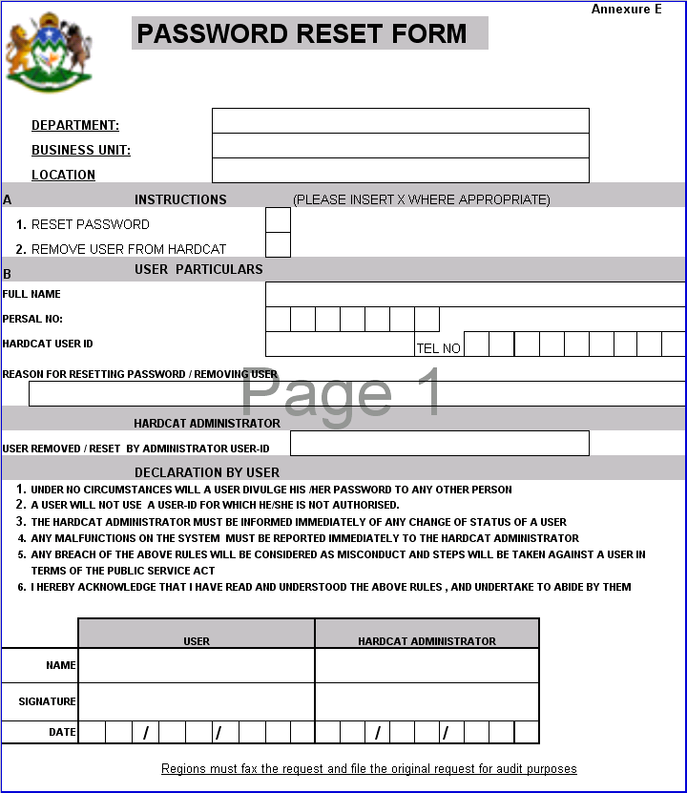

Annexure F

